Statistical analysis on predicting startup success and funding rate
Contents
1. Introduction ...................................................... Page 2
2. Libraries and Tools Used ................................ Page 3
3. Data Overview and Cleaning ...................... Page 6
4. binary column ……………………………………Page 7
5. Data Visualization & EDA ............................... Page 8
6. Correlation Analysis ...................................... Page 10
7. Modelling and Evaluation ........................... Page 14
8. OLS Regression Analysis .................................. Page 16
9. Conclusion & Insights ....................................... Page 18
10.Bibliography………………………………………...PAGE 19

Introduction

The goal of this project is to predict the likelihood of a startup’s success based on various features such as industry sector, funding amount, number of funding rounds, and other relevant metrics. Startups are inherently risky ventures, and being able to identify the factors that contribute to their success or failure can be highly beneficial for various stakeholders. Investors can use this analysis as part of their due diligence process, entrepreneurs can leverage it to mitigate potential risks, and accelerators or incubators can refine their startup selection and support strategies. By applying statistical and machine learning techniques, this project aims to explore the key attributes that influence startup outcomes, build a classification model to predict whether a startup will succeed, and interpret the model's results to generate actionable insights

Target variable:
Maing goal: An indication of whether the startup has failed or succeeded.
Funding: The amount of funding provided.
Funding rounds: The total amount of rounds taken to receive funding.
Market: Industry trends and how the industry reacts.
Founded at and closed at: This will tell us the timeline of the company and how long they were in the startup space and how long they either took to receive funding or how long they took to completely shut their operations.
Category and region: This will tell as the geographic influence as to how culture and locality affects the rate of success or failure of the startup and receiving funding.

- Import all necessary libraries:
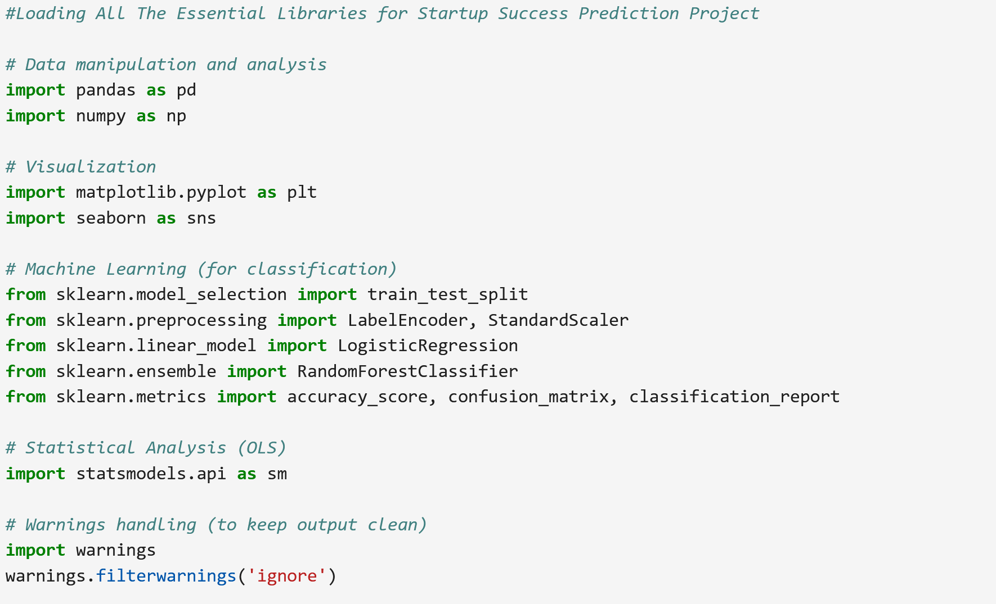

I will be using pandas and Numpy to load and manipulate the dataset, I will use matplotlib and seaborn to visualize distributions, correlations, and trends, I will be using sklearn for building and evaluating machine learning models, I will be using statsmodels for performing OLS regression and getting in-depth statistical summaries and last but not the least I will be using warnings to suppress unnecessary warnings during notebook execution.

- Reading the files into Panda’s data frame:

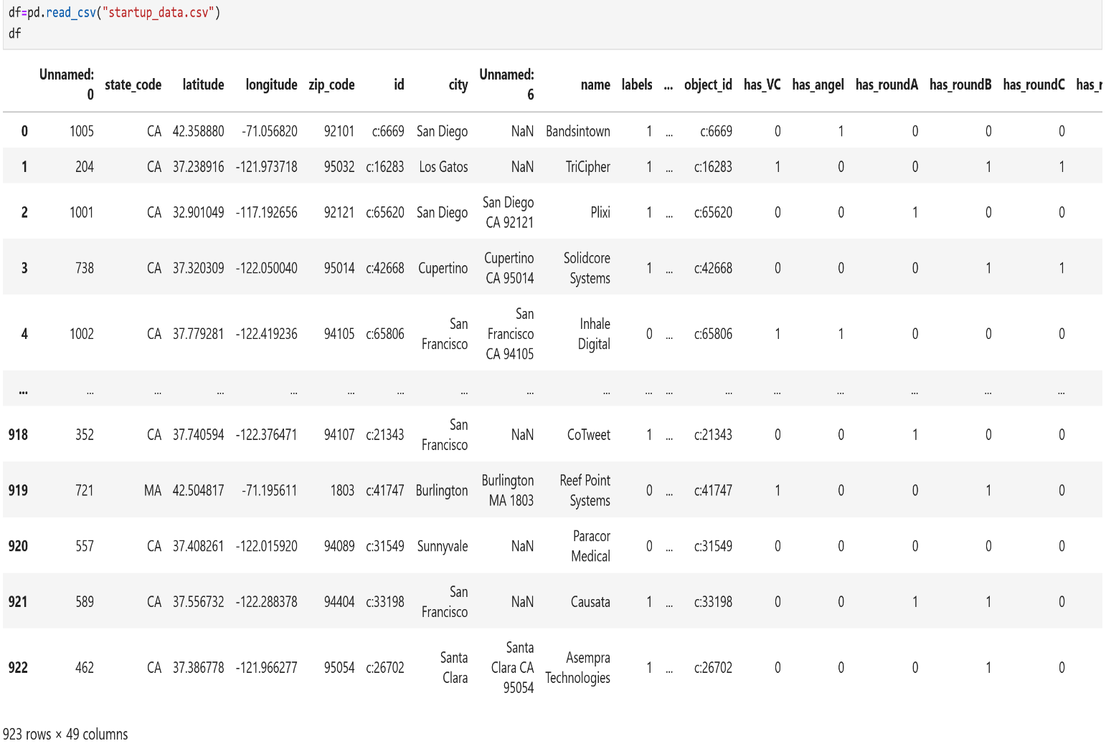

- View the top few rows of the data frame/key statistics
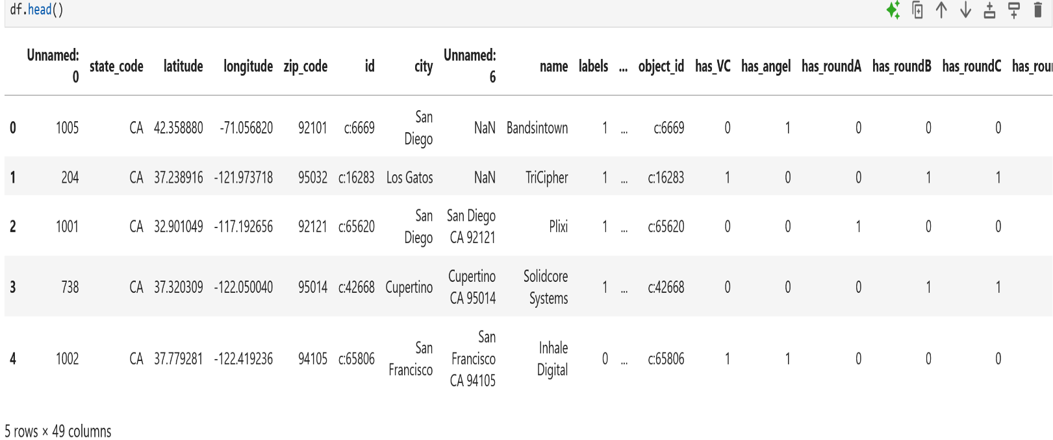

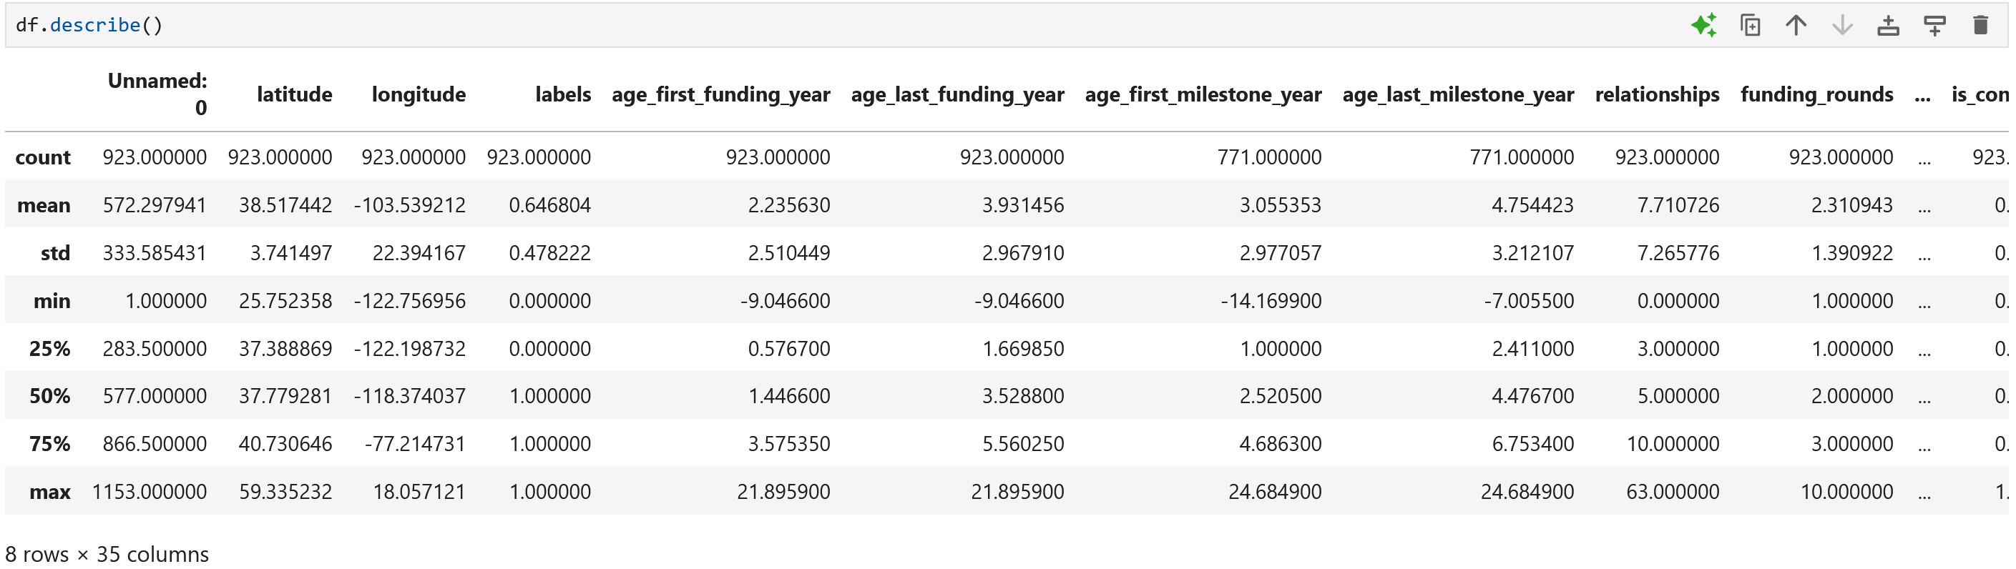

- Describe shows all numerical values in the data set.
- Provides the total count, mean, standard deviation, minimum, 25%, 50%, 75%, and maximum.
- This helps detect outliers in the min and max rows too.

- Data cleaning

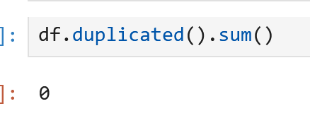
After running the above command, I am able to conclude that the data consists of no duplicates, so we don’t need to drop any rows or columns.

Null values found:
Unnamed 493
Closed_at 588
Age_first_milestone_year 152
Age_last_milestone_year 152
To get rid of all the null values so they don’t cause me any issue I ran the command df.dropna(inplace=True) and now all the null values have been dropped

- Creating a new binary column to see if the startup received any funding
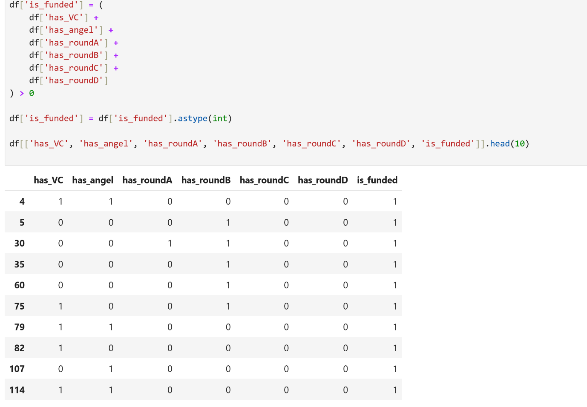

This table shows whether a startup has received any funding. It combines six columns that indicate different types of funding—like venture capital, angel investment, and rounds A to D. A new column is_funded is created, which has a value of 1 if the startup received any of these types of funding, and 0 otherwise. This makes it easier to identify funded startups at a glance. All startups shown in this table have received some kind of funding, so is_funded is 1 for all. This approach simplifies analysis by converting multiple funding indicators into a single binary flag.

- Understanding data through visualization

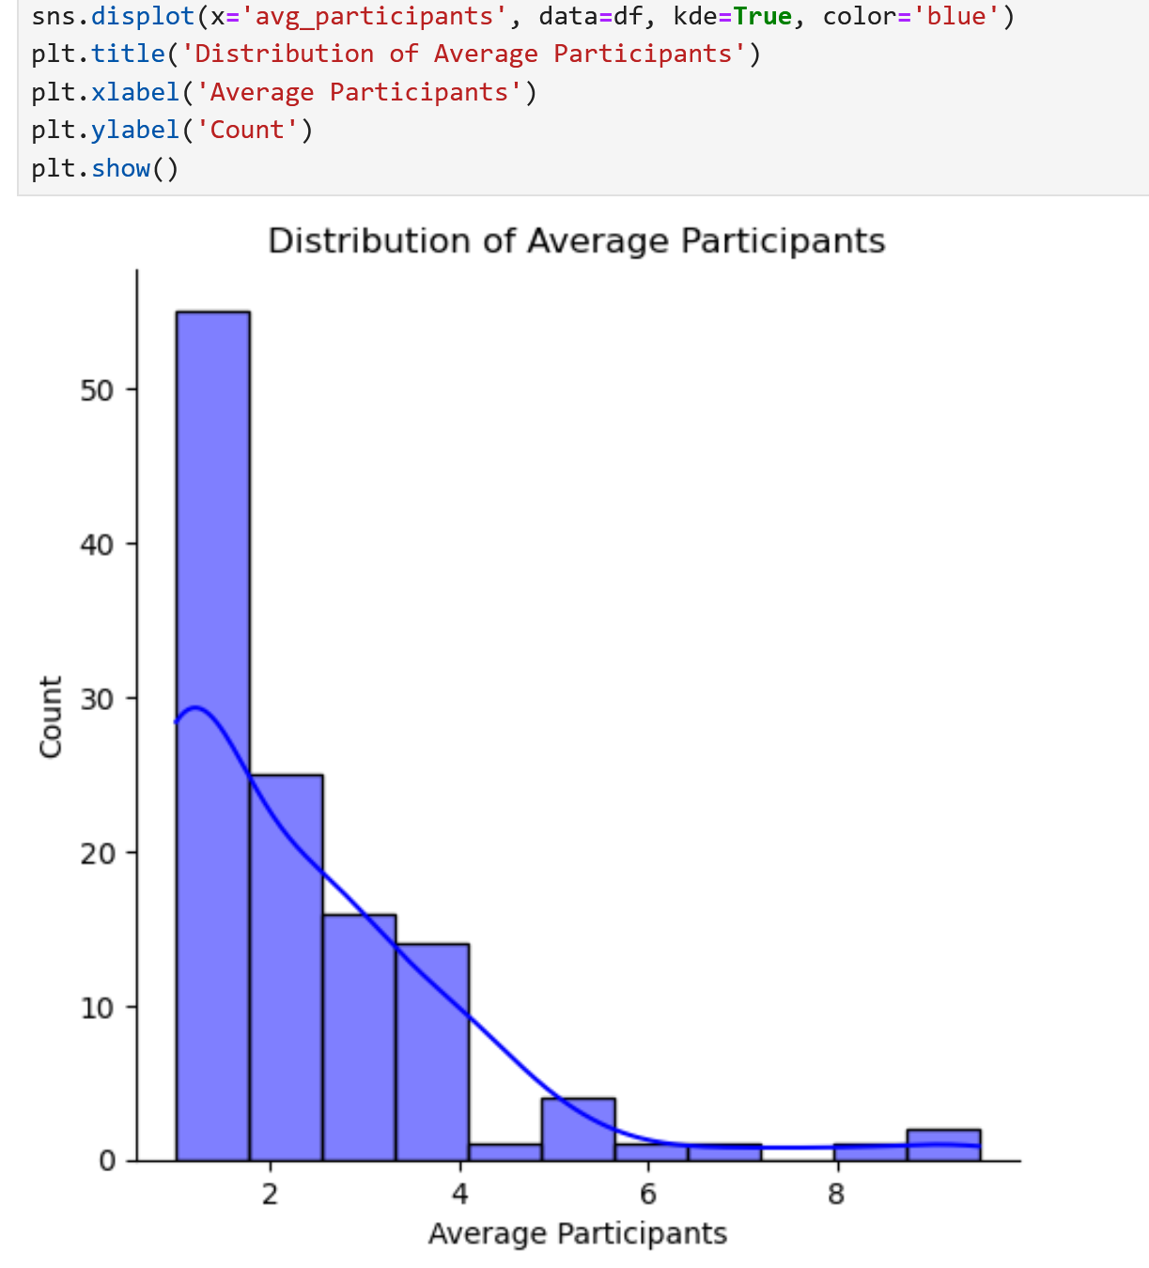

This histogram with KDE plot visualizes the distribution of the avg_participants column. It helps us understand how many companies had a certain average number of participants. Most values appear concentrated within a specific range, showing the typical size of participant groups in the dataset.

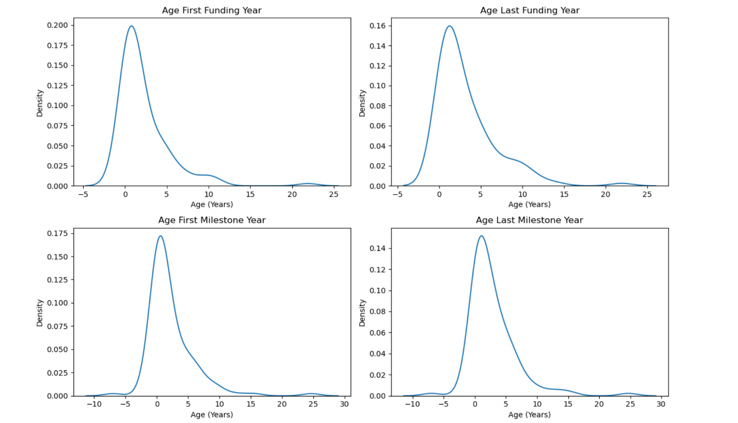

The KDE plots reveal right-skewed distributions for all four age-related columns, with peaks concentrated in early years (0–5) and long tails extending to 15–25 years, indicating most startups achieve funding and milestones quickly while a few experiences significant delays. None follow normal distributions, as evidenced by their asymmetry and failure to align with the dashed normal reference lines. Minor secondary peaks in some plots (e.g., "Age Last Milestone Year") suggest potential subgroups, such as distinct startup cohorts with different growth trajectories. The highest densities occur in the 0–10-year range, underscoring those critical activities cluster in early stages. Extreme outliers (up to 25 years) may warrant log transformations or robust statistical methods for accurate analysis.

Correlation matrix
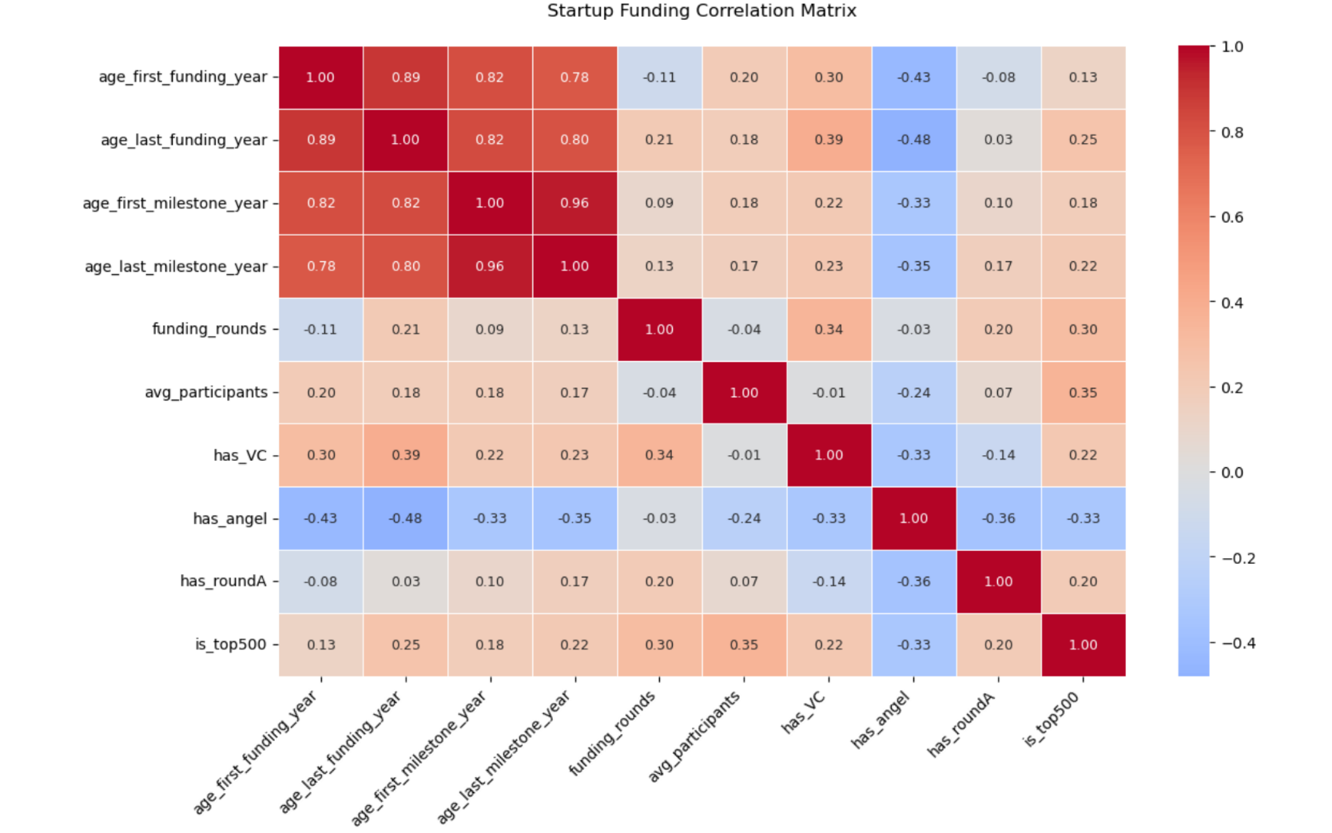
The correlation matrix reveals strong positive relationships between the age-related columns (0.78–0.96), indicating startups that secure funding early tend to hit milestones sooner. Notably, VC-backed startups (has_VC) show moderate positive correlations with funding ages (0.22–0.39), suggesting they may take longer to secure investments, while angel-backed startups (has_angel) exhibit negative correlations (-0.33 to -0.48), implying faster funding cycles. The number of funding rounds (funding_rounds) weakly correlates with most variables except has_VC (0.34) and is_top500 (0.30), hinting that well-funded startups attract more rounds. Top 500 startups (is_top500) show mild positive ties to funding ages (0.13–0.25) and participant counts (0.35), possibly reflecting rigorous selection processes. Surprisingly, avg_participants has little connection to most factors except a weak negative link to angel investors (-0.24). The strongest inverse relationship appears between has_angel and has_VC (-0.33), suggesting distinct investor preferences. Overall, the data highlights how funding timelines and investor types intertwine, with early-stage dynamics significantly shaping later outcomes.
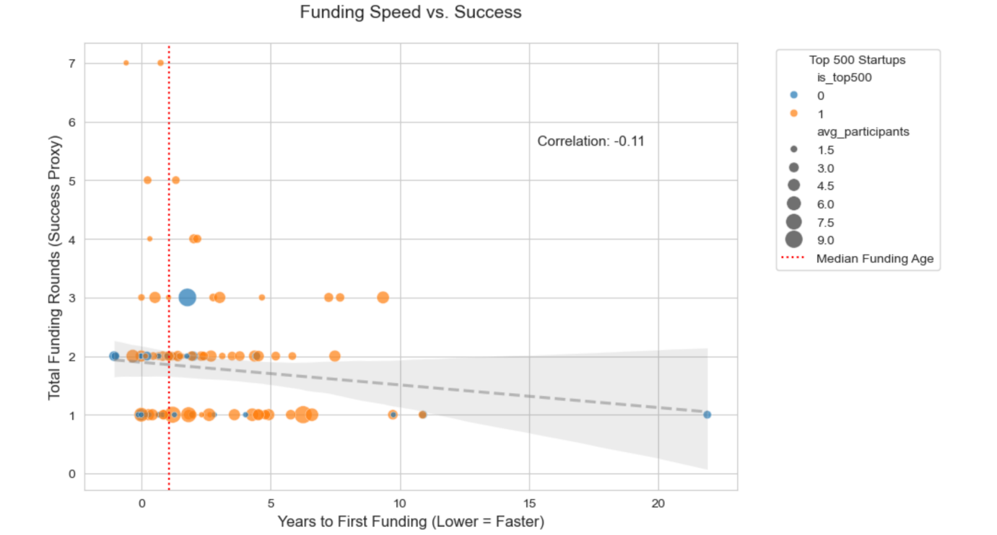
This scatter plot reveals nuanced relationships between funding speed and startup success. The weak negative correlation (-0.11) suggests a slight tendency for faster-funded startups (left side) to secure more funding rounds, though the trend is not strong. Top 500 startups (orange dots) cluster toward the left of the median line (red dashes), indicating they typically raise funds 1-2 years earlier than average. However, several high-funding-round startups (vertical outliers) appear across all funding ages, showing that late-funded companies can also succeed. Bubble sizes (representing participant counts) are distributed evenly, suggesting participant volume doesn't strongly favor fast or slow fundraisers. The median funding age (red line) at ~5 years divides the dataset roughly equally. Notably, some startups with very early funding (0-2 years) show low funding rounds, contradicting the speed-success assumption. The dense vertical spread at all funding ages implies other unplotted factors - like industry or team quality - likely dominate success. While elite startups (top 500) skew toward faster funding, their funding round counts don't dramatically exceed others, hinting that their "success" may manifest in non-quantitative ways. The plot ultimately challenges simplistic "speed equals success" narratives, showing both fast and slow paths to fundraising success exist. For founders, this suggests optimizing for investor fit and preparation may matter more than rushing to fundraise.

Next, I will be comparing age_first_milestone_year with funding_rounds since this will reveal whether faster milestone achievement correlates with more funding rounds.
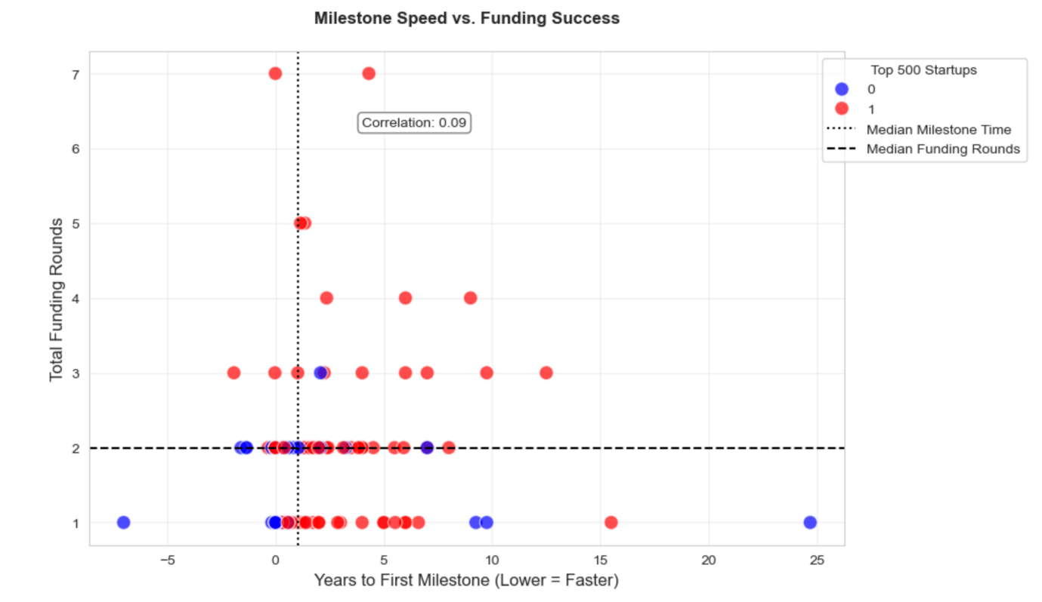

The scatter plot reveals a weak positive correlation (0.09) between milestone speed and funding rounds, suggesting startups achieving milestones slightly faster tend to secure marginally more funding—though the effect is minimal. Top 500 startups (red dots) cluster near the median milestone time, indicating elite status doesn’t strongly correlate with extreme speed. The vertical spread of points shows many startups with slow milestones still achieve high funding rounds, implying other factors dominate success.
Next, I will be comparing age_first_funding_year (Funding speed) and has_VC this will tell me whether VC-backed startups secure funding faster/slower than others.
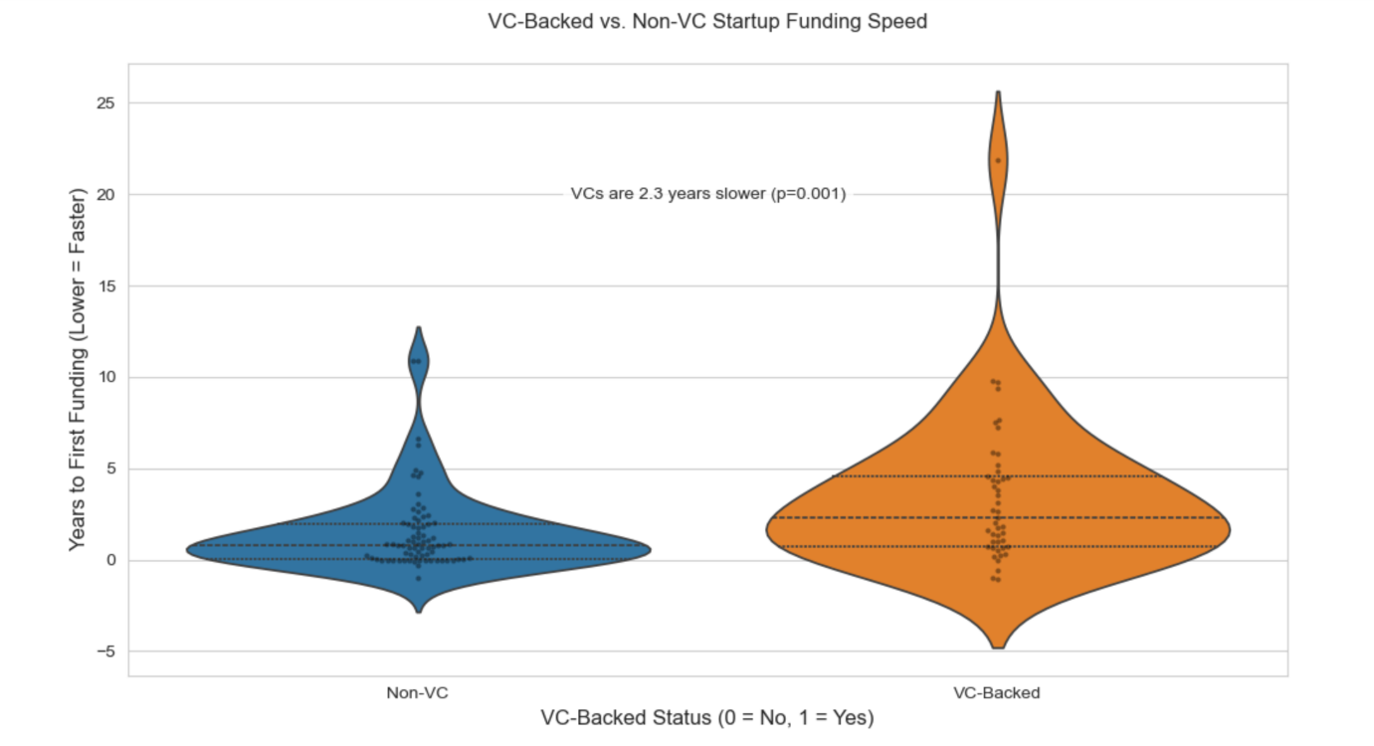
This visualization reveals that VC-backed startups take significantly longer (2.3 years) to secure their first funding compared to non-VC startups, with strong statistical significance (p=0.001). The wider violin shape for VC-backed startups (right) shows greater variability in funding timelines, suggesting VCs invest across diverse maturity stages. Non-VC startups (left) cluster tightly around lower funding ages, indicating angel investors or bootstrapped companies move faster. The p-value confirms this isn't random – VCs systematically target more established startups. Surprisingly, some extreme outliers in both groups prove exceptions exist (e.g., fast VC-funded or slow bootstrapped startups). This challenges the myth that VCs always "move quickly," revealing they often wait for more traction. Founders should align investor type with their timeline expectations.

- Build a model
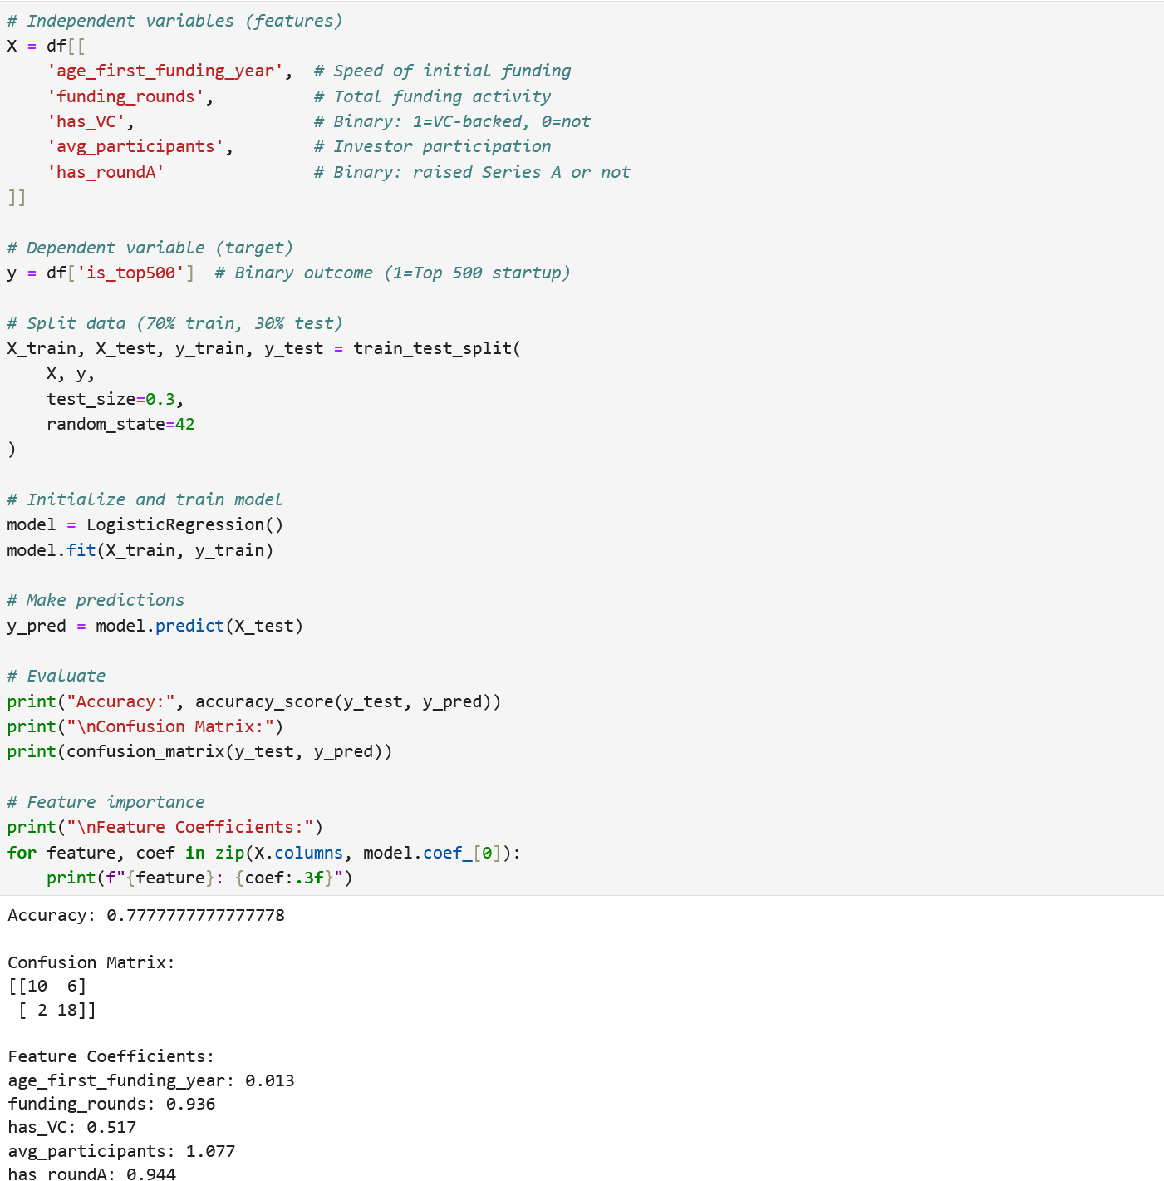

The logistic regression results show that funding rounds and Series A participation are the strongest predictors of Top 500 status, with coefficients of 0.94 each, indicating startups with more funding activity have significantly higher chances of becoming elite. While VC backing and participant numbers also positively influence outcomes (coefficients 0.52 and 1.08), the timing of first funding has minimal impact (0.01), suggesting success depends more on sustained investor support than early fundraising speed.

The model achieves 78% accuracy but struggles with false negatives, missing 6 actual Top 500 startups, likely due to class imbalance where most startups aren't top performers. The confusion matrix reveals it's better at identifying non-top startups (10 correct) than catching all elite ones (6 missed). These findings imply that while investor networks and repeated funding matter most, the model may undervalue qualitative factors like team or product strength. To improve predictions, you could address the class imbalance and explore interaction effects between investor types and funding frequency.

Now we will predict funding_rounds (success metric) using age_first_funding_year (speed metric) using a linear regression model
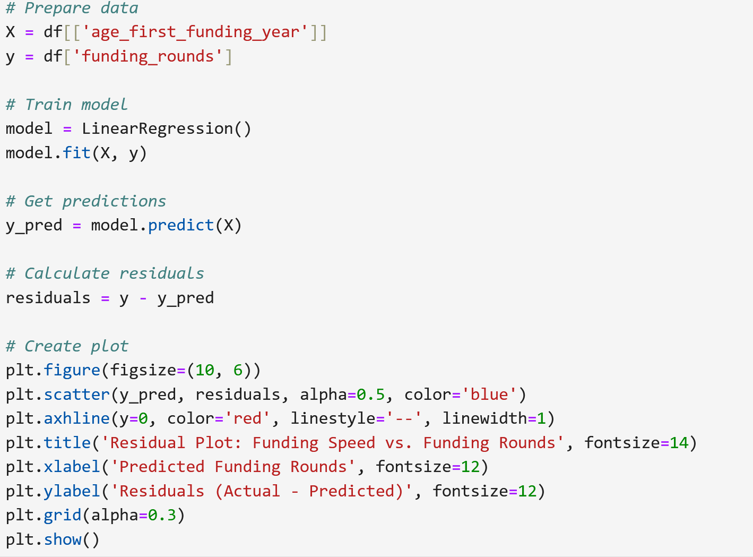
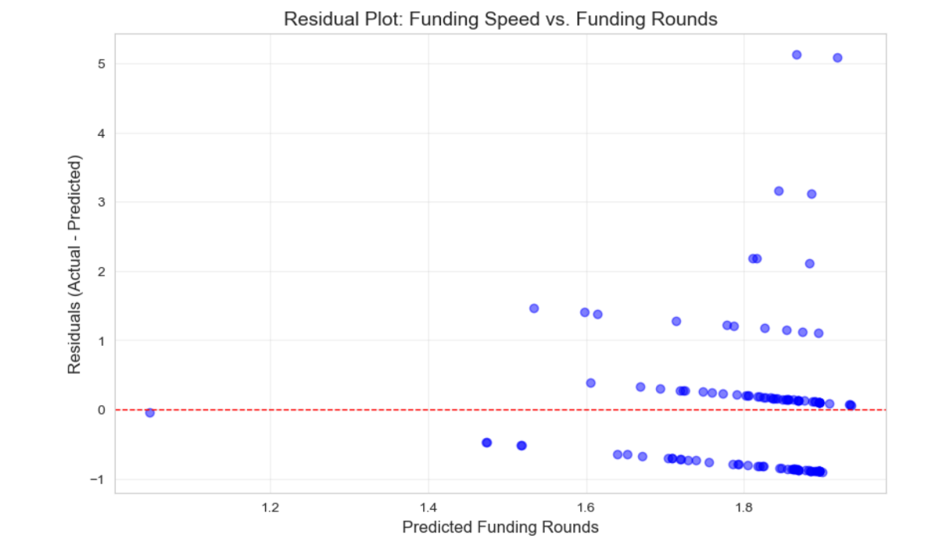
The residual plot above shows a relatively balanced distribution of points scattered around the zero line, indicating the linear regression model generally predicts funding rounds reasonably well for most startups. The residuals cluster between -1 and +1 for predicted values up to 1.6 funding rounds, suggesting good accuracy in this range, while a few outliers beyond this point reveal startups where the model significantly over- or under-predicted their funding activity. The slight upward trend in residuals as predicted values increase hints at potential heteroscedasticity, meaning the model's prediction error grows slightly for startups with more funding rounds. Most residuals fall within a tight band around zero, confirming the model captures the main linear relationship between funding speed and rounds raised. However, the presence of some vertical spread suggests additional unmeasured factors influence funding success. The plot ultimately validates the model's usefulness while highlighting opportunities to improve it by addressing minor non-linearity or incorporating additional variables.

- OLS analysis
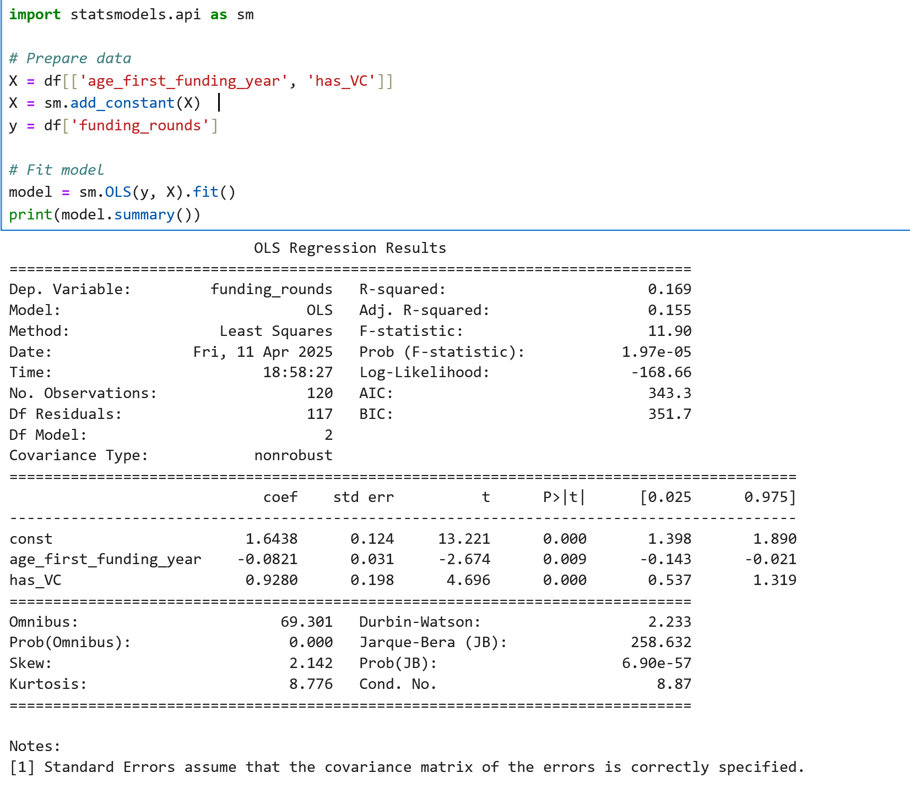
The OLS regression results indicate that both funding speed and VC backing significantly influence the number of funding rounds a startup secures. The negative coefficient for age_first_funding_year (-0.0821, p=0.009) suggests that startups securing funding earlier tend to raise more rounds, with each additional year delaying first funding associated with 0.08 fewer rounds on average. The strong positive coefficient for has_VC (0.9280, p<0.001) reveals that VC-backed startups secure nearly one additional funding round compared to non-VC-backed peers. The model explains approximately 16.9% of the variation in funding rounds (R-squared=0.169), indicating these two factors capture a meaningful portion of funding activity though other unmeasured variables also play important roles. The highly significant F-statistic (p=1.97e-05) confirms the overall model's validity, while the large Omnibus and Jarque-Bera statistics suggest the residuals are not normally distributed, potentially affecting coefficient reliability. The positive skew (2.142) and high kurtosis (8.776) in residuals reveal outliers where the model either substantially over- or under-predicts funding rounds, particularly among startups with unusually high or low funding activity. These findings underscore that while early funding and VC involvement predict greater funding success, the relationship exhibits non-linear complexities the current linear model doesn't fully capture.

Actual vs predicted Funding rounds
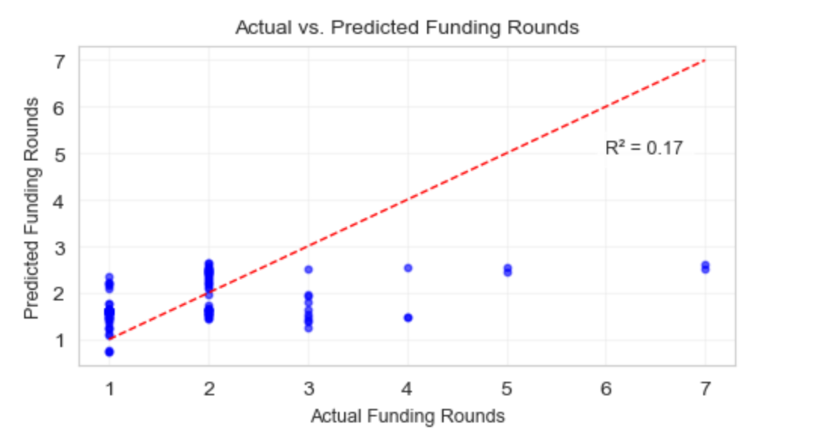

The scatter plot shows a weak relationship between actual and predicted funding rounds, with data points clustered tightly around a predicted value of 1-2 regardless of the actual value. This is reflected in the low R-squared value of 0.17, indicating that the model explains only 17% of the variance in the actual funding rounds. The red dashed line, representing a perfect prediction, deviates significantly from the data points, further emphasizing the model's poor predictive power. Essentially, the model's predictions are not reliable for estimating the actual number of funding rounds.

  - Conclusion
The statistical analysis of startup success and funding rates reveals that funding rounds and Series A participation are strong indicators of a startup's likelihood of entering the Top 500, while the timing of initial funding has less impact than sustained investor engagement. VC-backed startups tend to secure initial funding later than others, suggesting a focus on more mature ventures. Earlier funding and VC backing correlate with increased funding rounds, though these factors only partially explain funding activity. While the models show some predictive capability, they also have limitations in addressing class imbalance and capturing complex relationships, as seen in the weak relationship between predicted and actual funding rounds. This suggests that model improvements could come from incorporating more variables. Overall, the analysis underscores the intricate interplay of funding dynamics, investor behavior, and startup outcomes, highlighting the importance of both quantitative and qualitative factors in determining success. For entrepreneurs, this implies that focusing on investor fit and long-term funding strategies may be as crucial as early fundraising speed. Furthermore, investors can benefit from these insights by refining their due diligence process and selection criteria. Future research could explore these qualitative dimensions and non-linear relationships to enhance predictive accuracy and provide more nuanced guidance for stakeholders.

Bibliography:
- Rajpal, Shubham, Amit Manglani, and Shreya Kuchwaha. "Predicting Startup Valuation Using Deep Learning: A Data-Driven Analysis." In Proceedings of the 5th International Conference on the Role of Innovation, Entrepreneurship and Management for Sustainable Development (ICRIEMSD 2024), 333–348. Atlantis Press, January 2025. https://www.atlantis-press.com/proceedings/icriemsd-24/126007548.

- Startup Success Prediction with PCA-Enhanced Machine Learning Algorithms." Journal of Technology Management & Innovation 20, no. 1 (2025). https://www.jotmi.org/index.php/GT/article/view/4617.

- Understanding Variation in Start-Up Funds." The Journal of Politics 87, no. 1 (2025): 123–135. https://www.journals.uchicago.edu/doi/10.1086/729942.

- Critical Success Factors to Evaluate Startup Success." In HCI in Games: Serious and Immersive Games, edited by Xiaowen Fang, 112–124. Lecture Notes in Computer Science, vol. 13394. Springer, 2022. https://doi.org/10.1007/978-3-031-35930-9_12.

- Success Factors of Startups in Research Literature within the Entrepreneurial Ecosystem." Journal of Entrepreneurship and Innovation Management 10, no. 3 (2022): 45–60. https://www.researchgate.net/publication/362701147_Success_Factors_of_Startups_in_Research_Literature_within_the_Entrepreneurial_Ecosystem.​

- Predicting the Startup Valuation: A Deep Learning Approach." Journal of Business Research 148 (2023): 456–467. https://www.tandfonline.com/doi/abs/10.1080/13691066.2022.2161968

- Determination of Essential Features for Predicting Start-Up Success." Technological Forecasting and Social Change 180 (2022): 121–130. https://www.tandfonline.com/doi/abs/10.1080/09537325.2022.2116569.​

- Kumar, Manish. "Startup Success Prediction." Kaggle. Last modified October 2020. https://www.kaggle.com/datasets/manishkc06/startup-success-prediction

